Houston is provided month the EIA option values (noted in red):

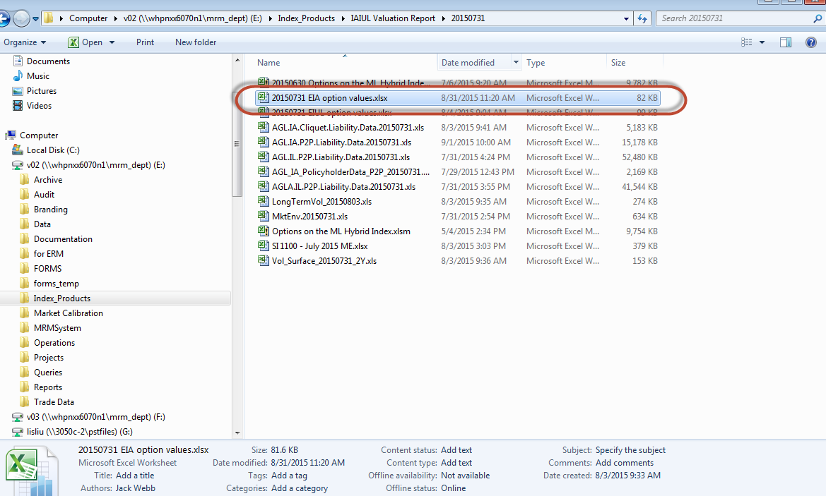

There are 2 inputs to the EIA option value: 1) Matlab results file for liability valuation data for IA P2P and IA Cliquet, 2) JAVAH – SI 1100 File

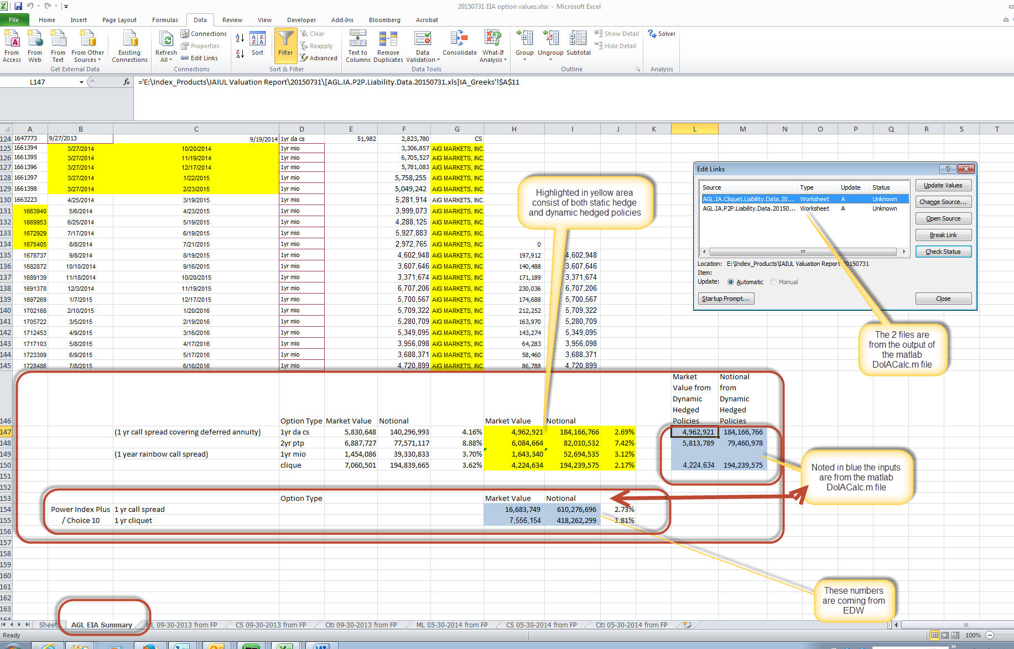

1) MATLAB INPUT (see edit link):

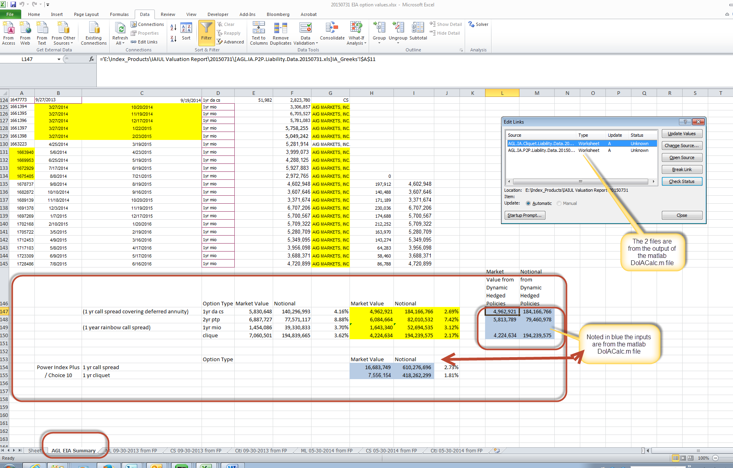

2) JAVAH – SI 1100 File

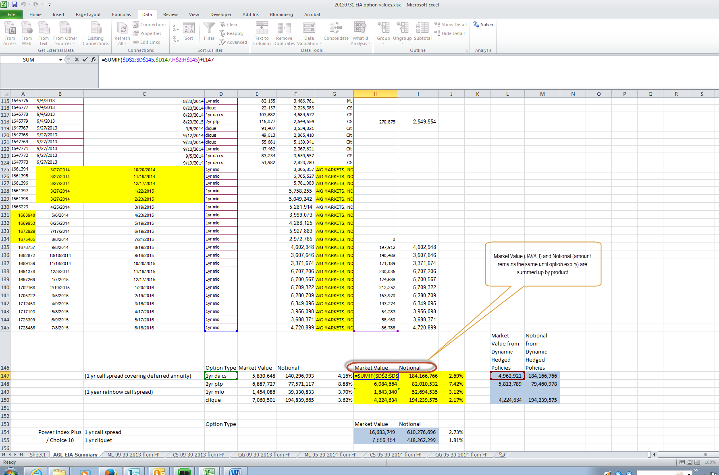

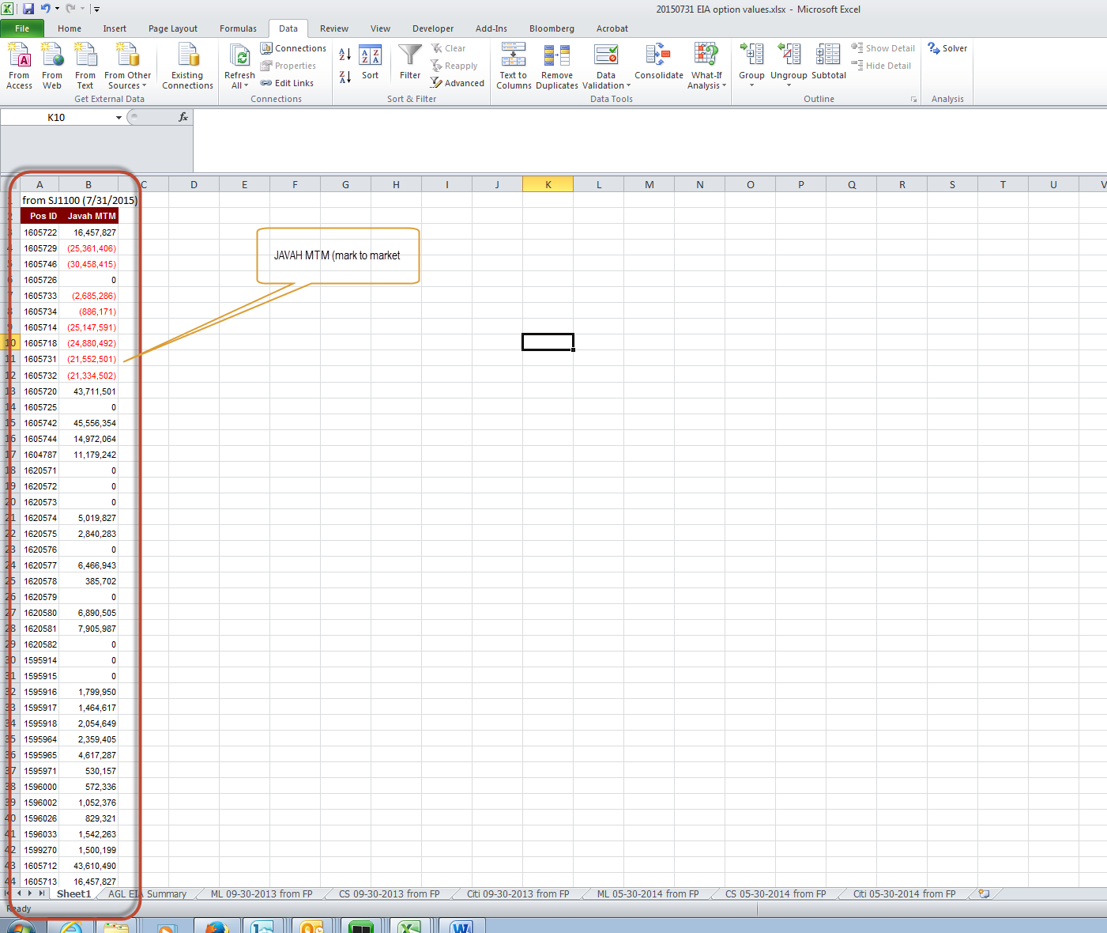

The bottom half of the spreadsheet in the AGL EIA Summary (row 154 & 155) comes from EDW:



Non-EDW Values (Jeffrey to confirm where the source is coming from):

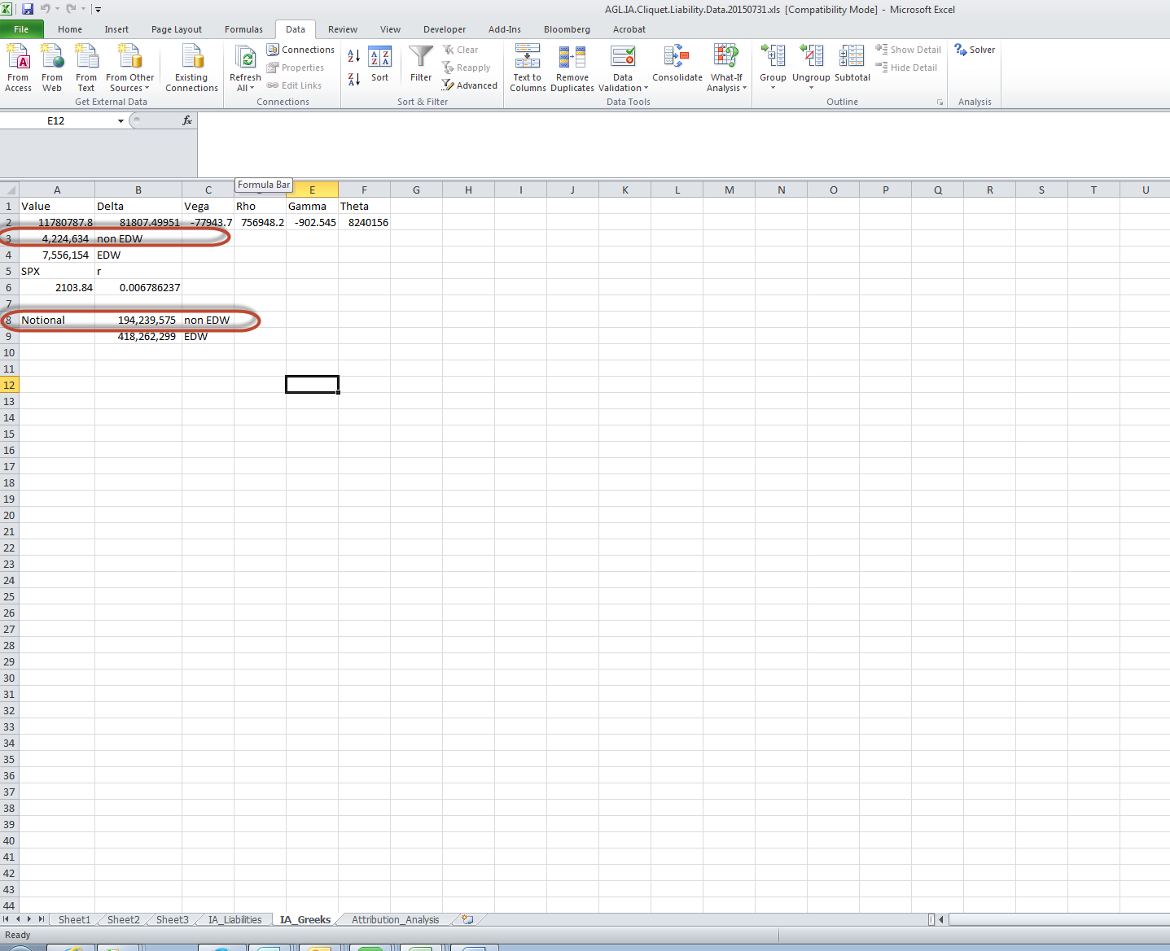

EDW values:

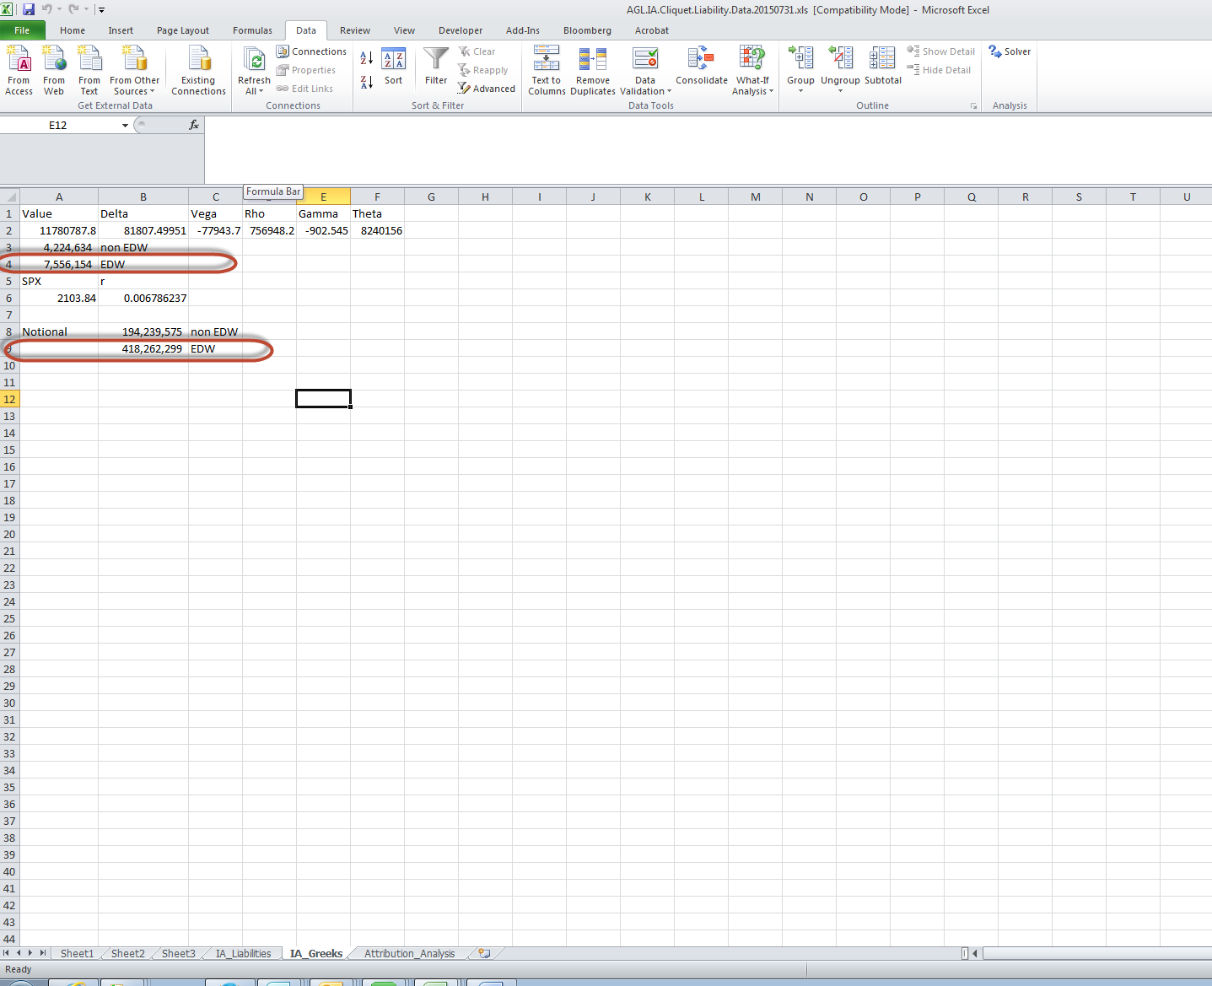

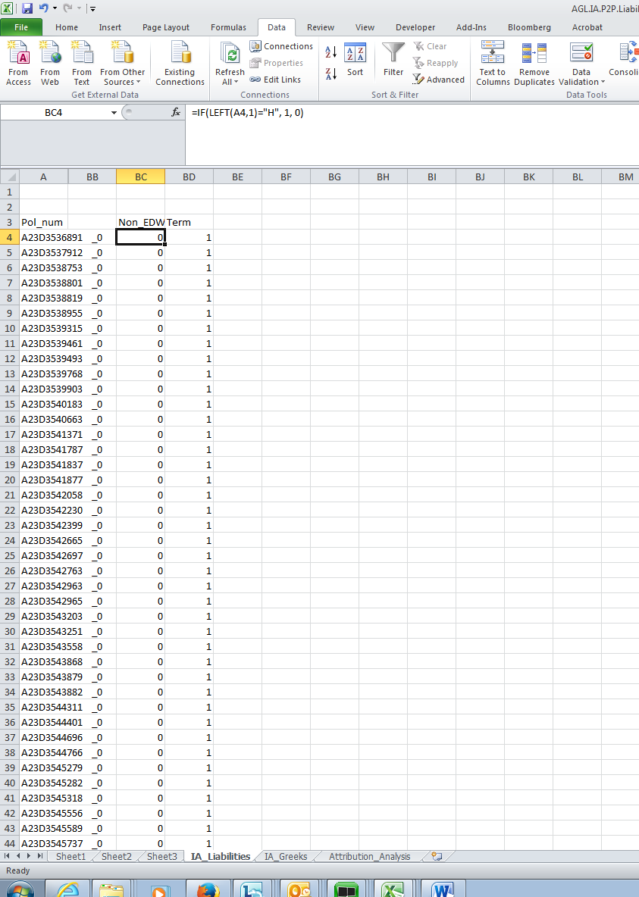

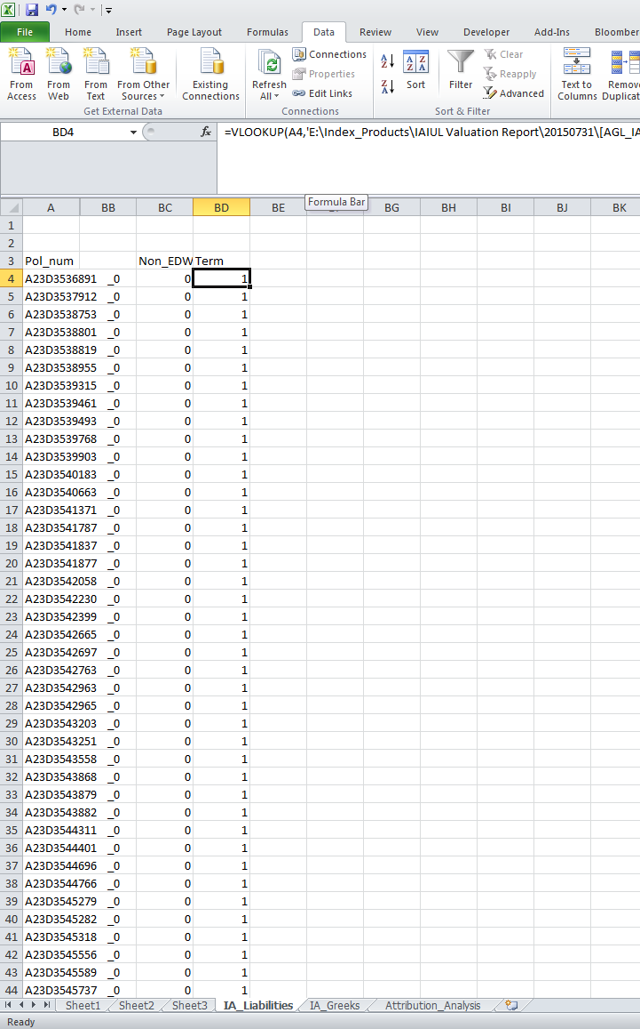

The 2 screenshots noted above come from the below file (this file is generated by the MRM database and saved here:

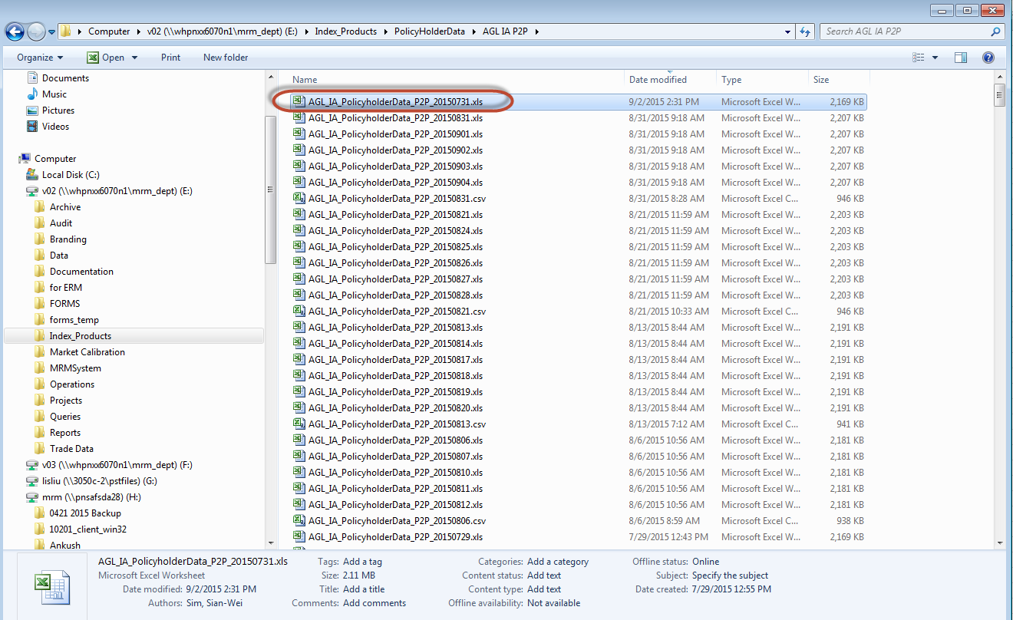

This is the file:

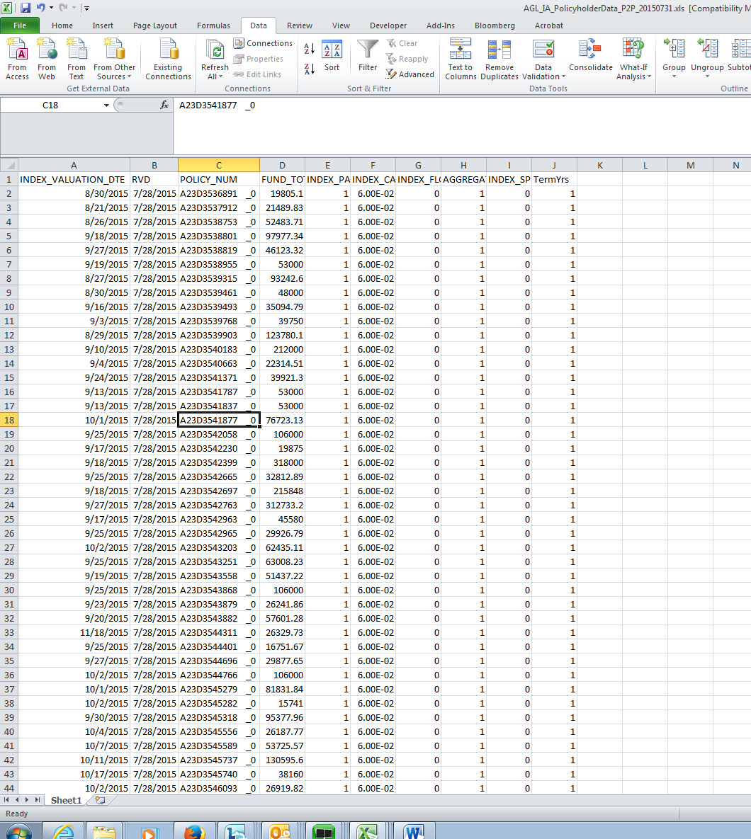

Note – Rainbow Options are static hedged which means the fund value is supposed to mirror the notional of the option bought for hedge. The fund value is driven by policy holder data.

Emmanuel is reviewing the notional for the following and comparing it to the prior month for reasonableness – Need to define reasonableness. (see print screen below):

|  |
| --- |
| * 1yr da cs – deffered annuity call spread |
| * 2yr ptp – call spread |
| * 1yr mio – 1year rainbow call spread |
| * Cliquet – Monthly sum cap |

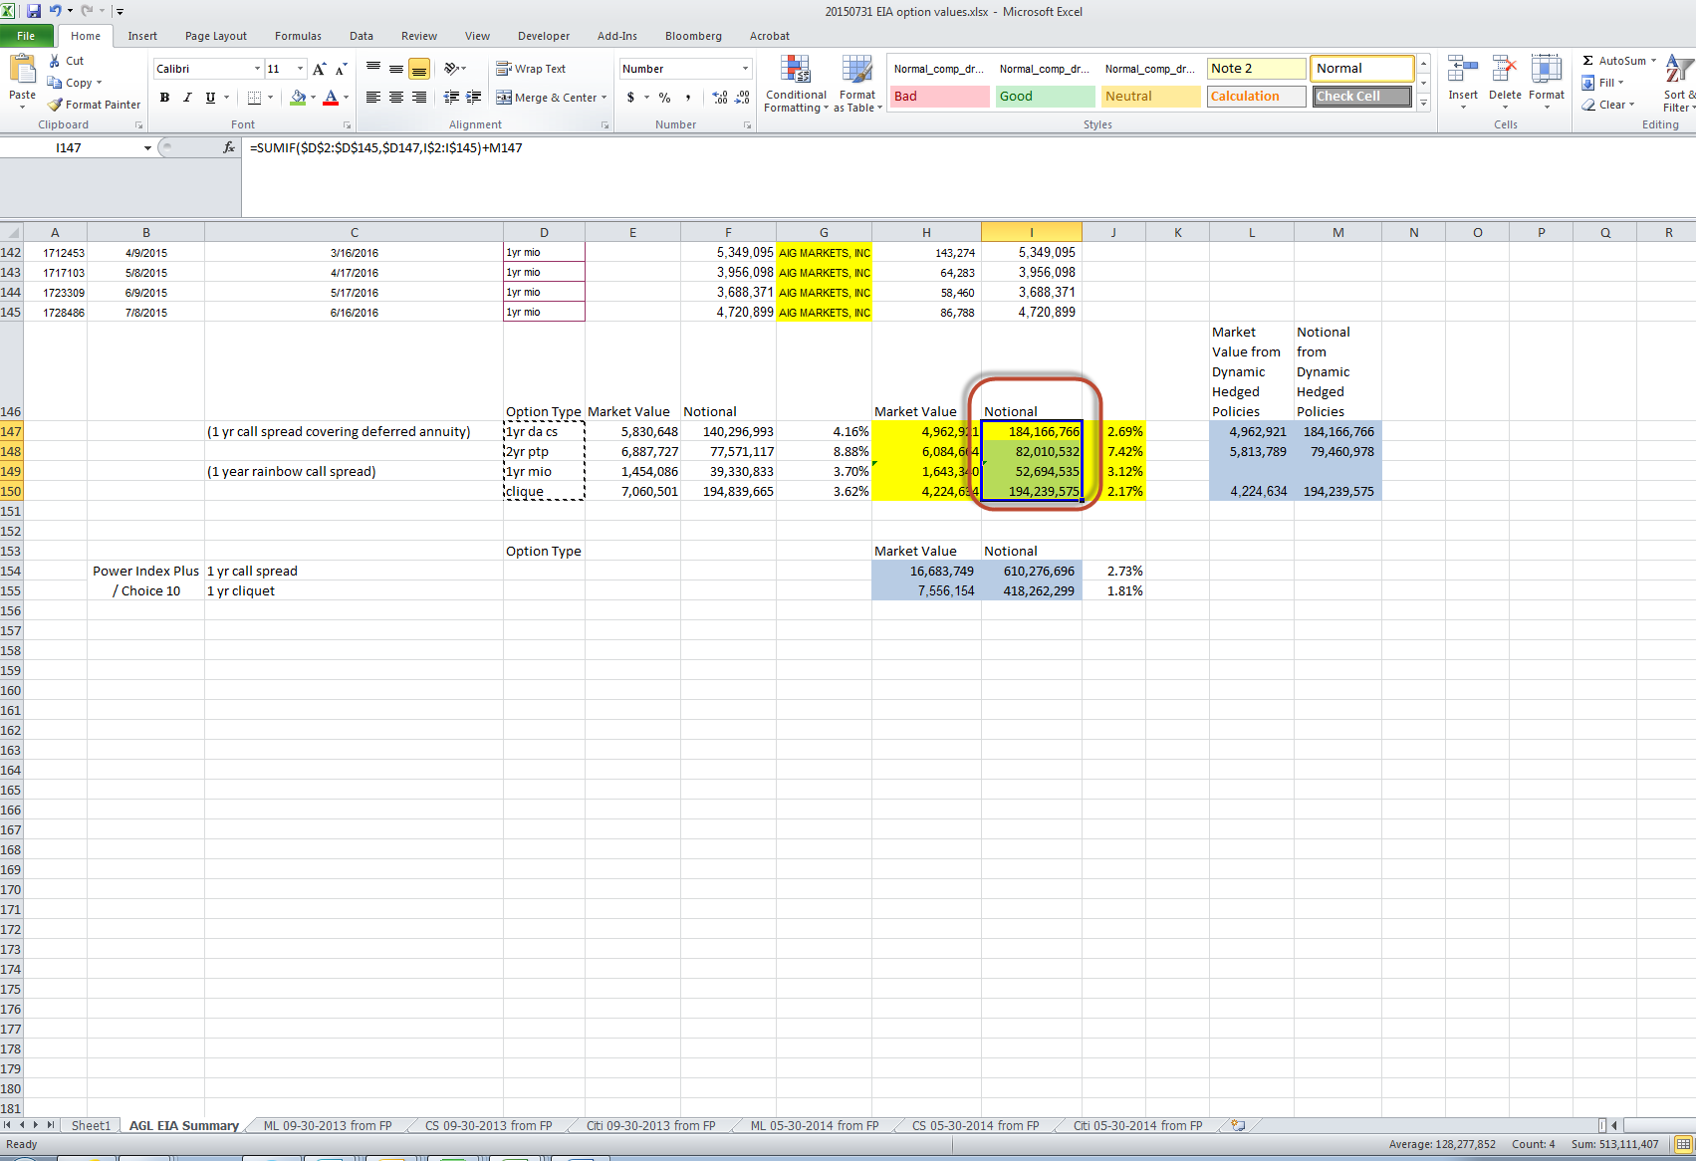

Emmanuel is also reviewing the rainbow notional to make sure any new options bought are included in the total notional:

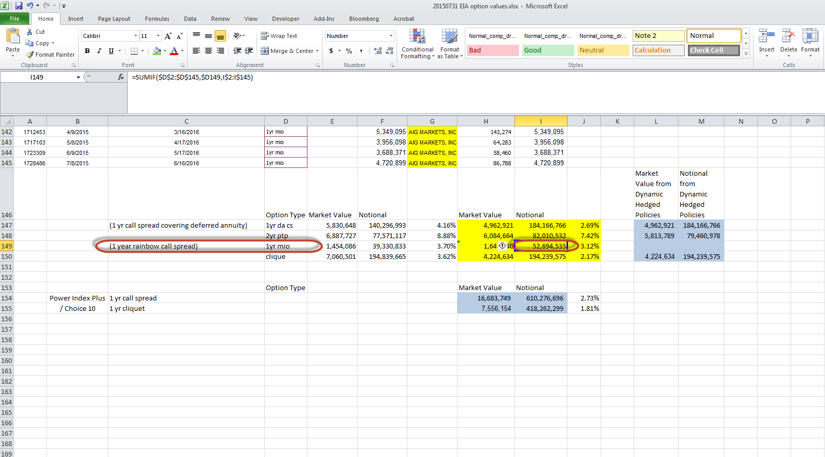

This is a listing of Rainbow option inventory. As the options expire, it is removed from the list/indicator built in the formula (expired = 0). Similarly, if new options are bought it is added to the below list:

